Analyzing GDP dependence on Import

Correlation matrix

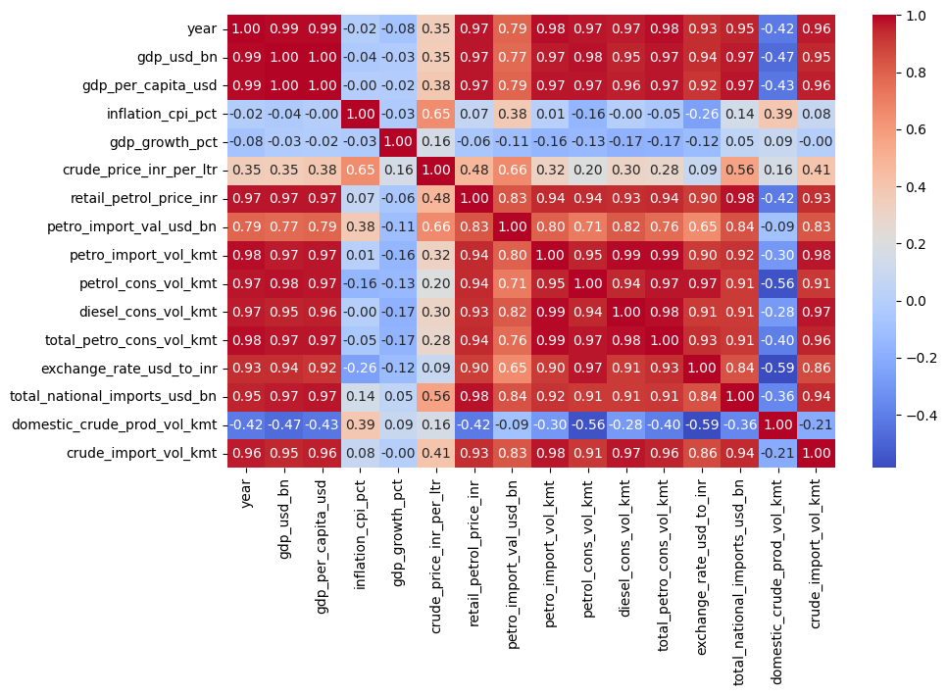
Conclusion
1. Strong Link Between Economic Growth, Imports, and Consumption
- There is an almost perfect positive correlation (0.97 to 0.99) between year, gdp_usd_bn, gdp_per_capita_usd, and consumption metrics like total_petro_cons_vol_kmt and diesel_cons_vol_kmt.
- The GDP has grown over the years but the growth is heavely dependent on consumption of Fuel and import of energy sources.
2. The Decline or Stagnation of Domestic Production
- negative correlations of Domentic crude oil production with almost every major metric. It correlates negatively with year (-0.42), gdp_usd_bn (-0.47), and total_petro_cons_vol_kmt (-0.40).
- Domestic crude oil production is declining or failing to scale with the growing economy. While consumption and imports are surging upward over the years, domestic production is moving in the opposite direction.
- It is a not a good sign as growth is dependent on the other countries and global disruptions can hamper the growth of country
3. Retail Prices Disconnected from Raw Crude Prices
- retail_petrol_price_inr only has a moderate correlation (0.48) with crude_price_inr_per_ltr. However, the retail price has a massive correlation with gdp_usd_bn (0.97) and exchange_rate(0.9).
- The price consumers pay at the pump is driven much more by long-term economic scaling factors (such as cumulative inflation, exchange rates, and compounding government taxes over time) than by the actual fluctuating price of raw crude oil.
4. Crude Oil's Impact on Inflation
- Crude_price_inr_per_ltr shows a moderate-to-strong correlation (0.65) with inflation_cpi_pct. This is the strongest correlation the inflation metric has with any variable on the board.
- Raw crude oil prices are a noticeable driver of consumer inflation. When crude prices rise, it tends to push the CPI up.
5. Exchange Rate Pressures
- exchange_rate_usd_to_inr correlates strongly with year (0.93), retail_petrol_price_inr (0.90), and total_national_imports_usd_bn (0.84).
- The depreciation of the Rupee against the Dollar over time is closely linked to the rising national import bill and the higher retail fuel prices faced by consumers.
- The rising dependency on Imported fuel and depreciating rupee value are the main drivers of inflation.
6. Independence of the Growth Rate
- GDP_growth_pct (the rate of growth) displays very weak correlations (near 0) with absolute metrics like gdp_usd_bn and consumption volumes.
- Year-over-year percentage growth fluctuates independently of the economy's total size. A larger economy does not inherently mean a faster or slower rate of growth.

Outlier Check

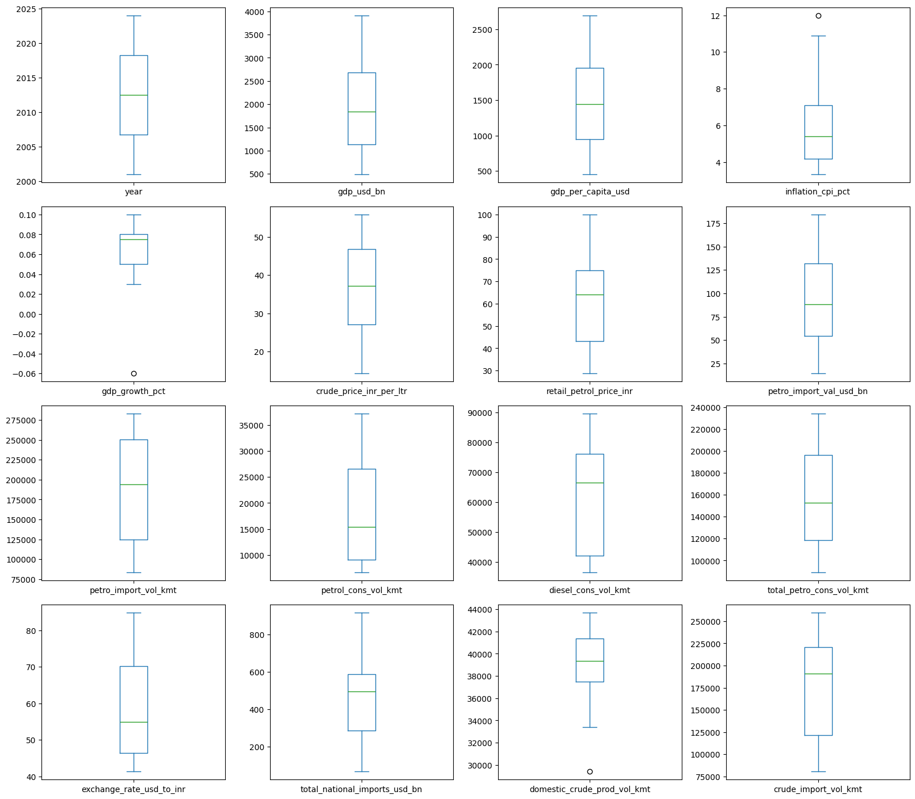
Conclusions
- gdp_growth_pct: one -0.06 (-6. %) in 2020 – shows the slowdown of economy due to corona effect
- inflation_cpi_pct: There is a high positive outlier near 12%. – due to severe food shortage after the 2008 global crises
- domestic_crude_prod_vol_kmt: There is a low negative outlier just under 30,000 kmt, indicating domestic production dropped significantly below its usual range.

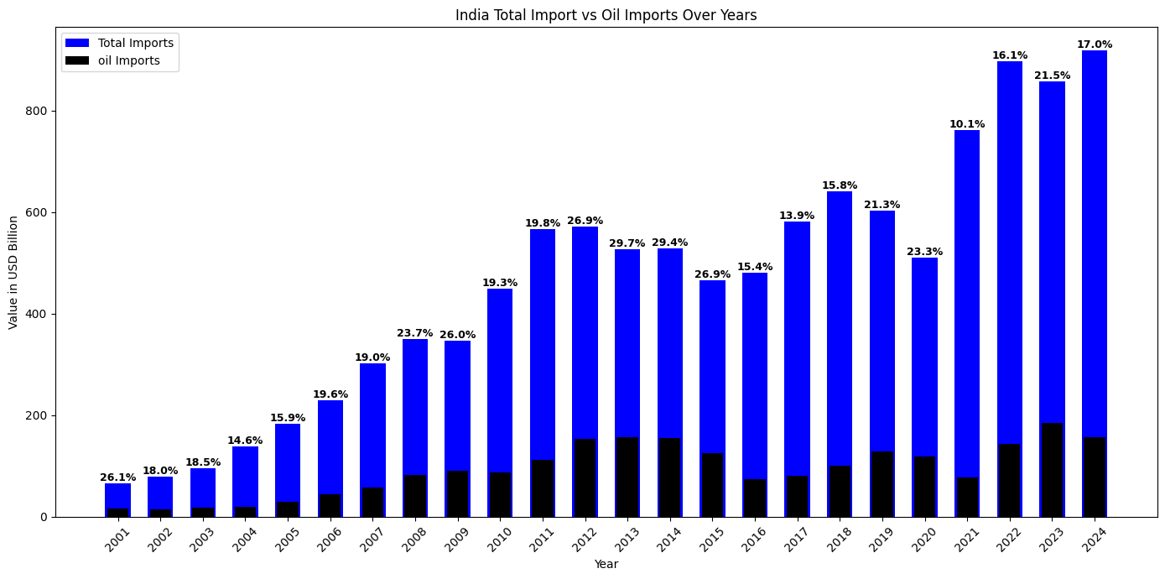
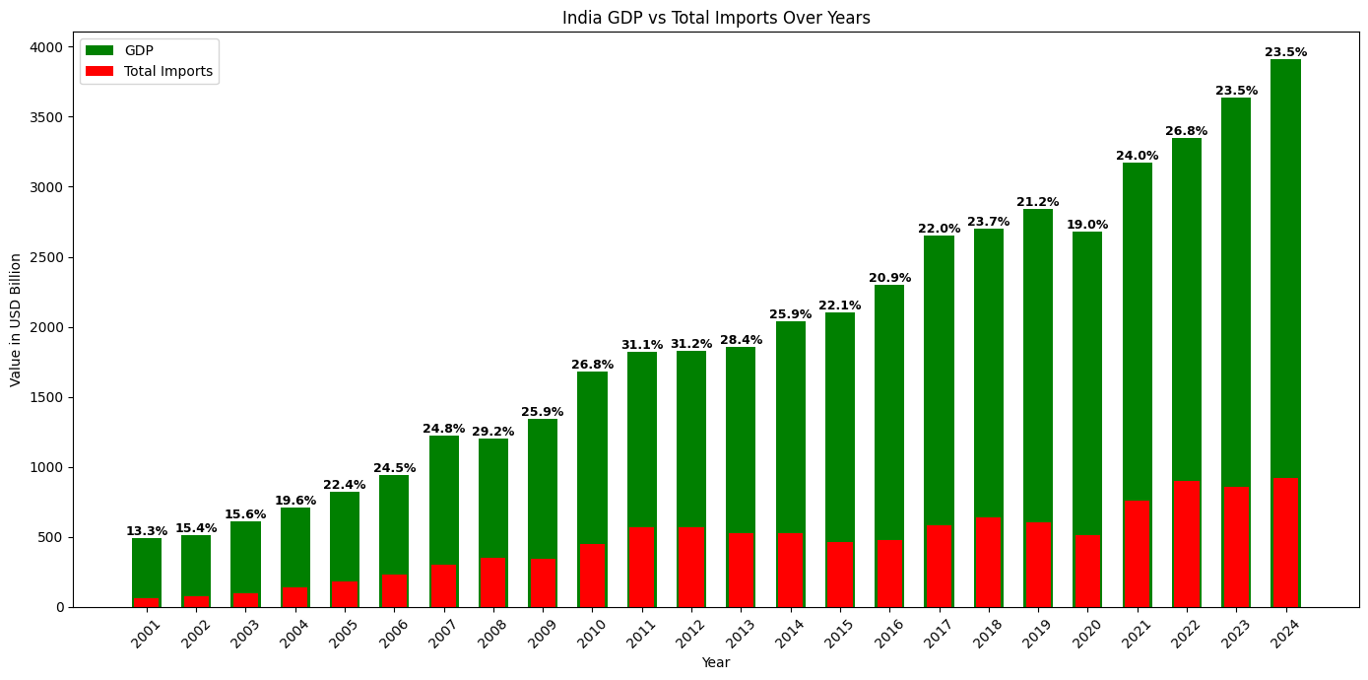
Load of Import on GDP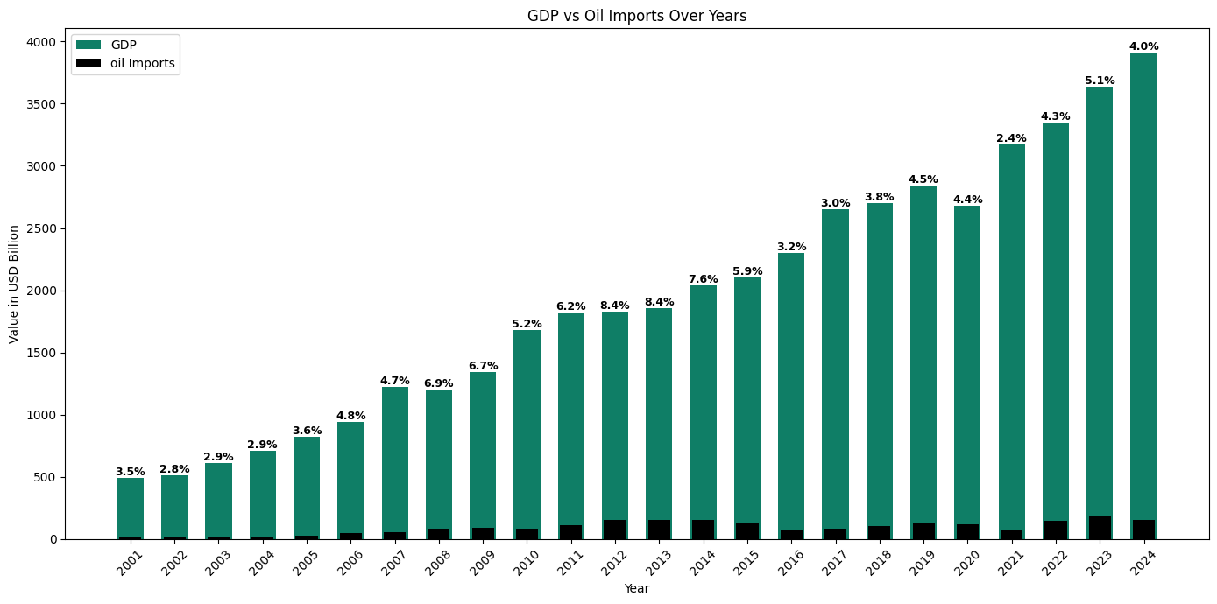

- The import is a major burden on gdp, and even among impot oil import comprises around 17 % of total import
- If we want to reduce import, reducing petrol import is one of the most efficient way to secure energy security

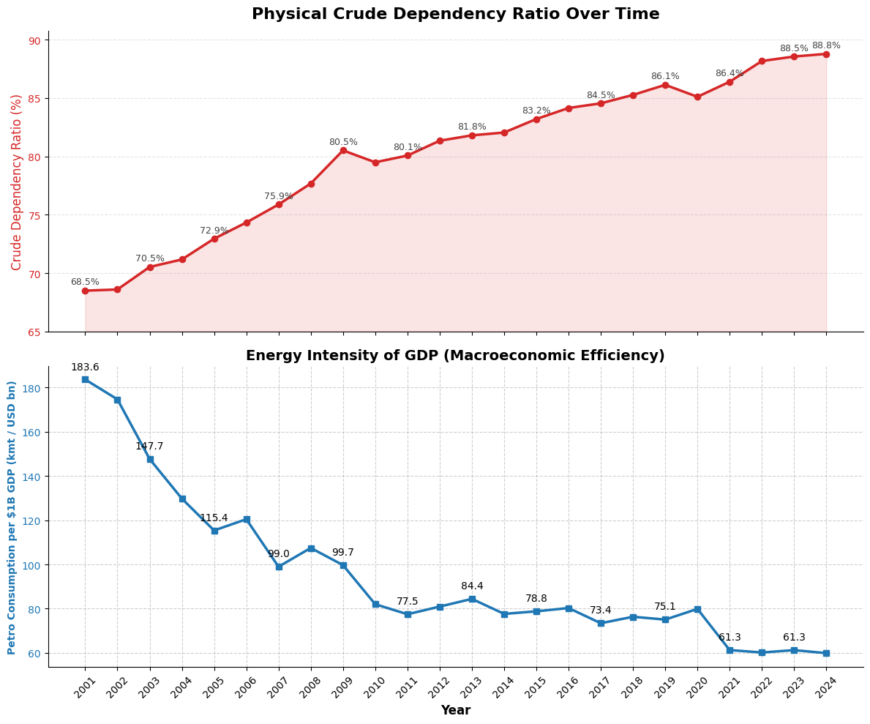
- India’s physical dependence on imported crude has risen sharply and persistently, increasing from 68.5% in 2001 to 88.8% in 2024.
- At the same time, the energy intensity of GDP has fallen substantially, from 183.6 KMT per $1B GDP in 2001 to 61.3 in 2024. This indicates that the economy now generates far more GDP per unit of petroleum consumed than it did two decades ago.
- Energy security has weakened because India is becoming more import-dependent for crude.
- Macroeconomic efficiency has improved because the economy is using petroleum more productively to generate output.
India is becoming more economically efficient with petroleum, but simultaneously more strategically vulnerable because that petroleum is increasingly import-dependent.

PCA
Removed "gdp_per_capita_usd", "gdp_growth_pct" and “year” for better pca
and also “gdp_usd_bn” as it is the target variable

For 95% variance ration only PCA 1, PCA 2, PCA 3 is enough

